Problem 1
Sketch the spectrum of the following periodic signals:

Solution:
- For this signal

Since f is rational, then the signal is periodic with a fundamental period N = 5
Then the signal can be described as

where
We can either compute c₀, c₁, …, c₄ or given that we can describe x(n) as

This is the same form as the Fourier series
So, we can conclude that from the first exponential, c₁ = -1.5j
The second exponential would correspond to c₋₁ = 1.5j. However, we cannot have k = -1 since k = 0, 1, …, 4. Given the periodicity property of the coefficients, we can conclude that c₋₁ = c₋₁₊₅ = c₄ = 1.5j
All other coefficients c₀, c₂, c₃ = 0
Each coefficient can be described as magnitude and phase as follows

The spectrum can be described as follows

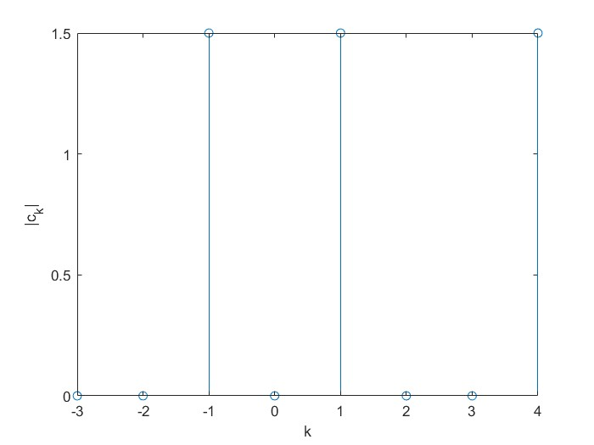

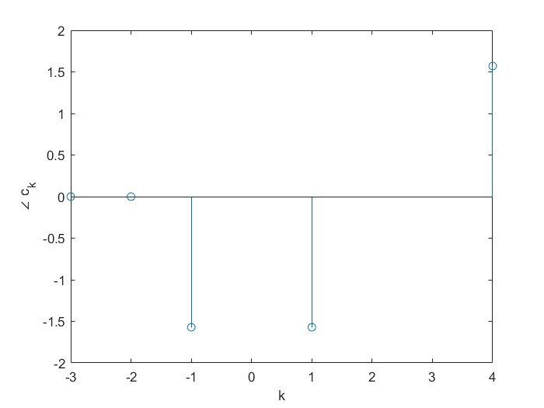

- For this signal

Since f is rational, then the signal is periodic with a fundamental period N = 15
Then the signal can be described as

where
We can either compute c₀, c₁, …, c₁₄ or given that we can describe x(n) as

This is the same form as the Fourier series

So, we can conclude that from the first exponential, c₅ = 0.5
The second exponential would correspond to c₆ = -1.5j
The third exponential would correspond to c₉ = 1.5j
The last exponential would correspond to c₁₀ = 0.5
All other coefficients c₀, c₁, c₂, c₃, c₄, c₇, c₈, c₁₁, c₁₂, c₁₃, c₁₄ = 0
Each coefficient can be described as magnitude and phase as follows

The spectrum can be described as follows

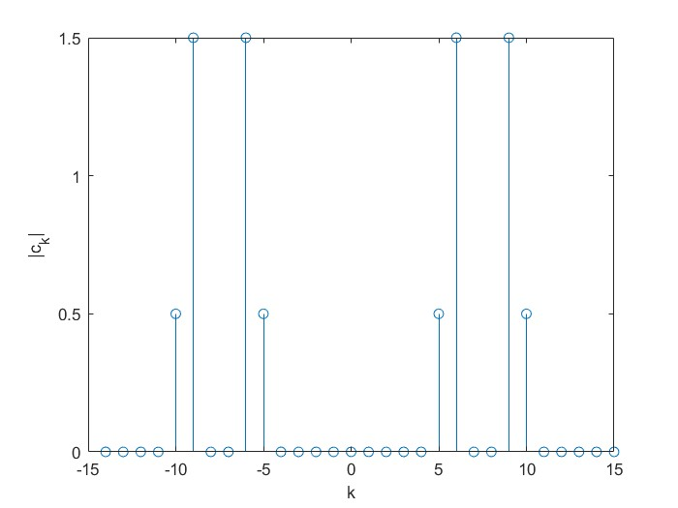

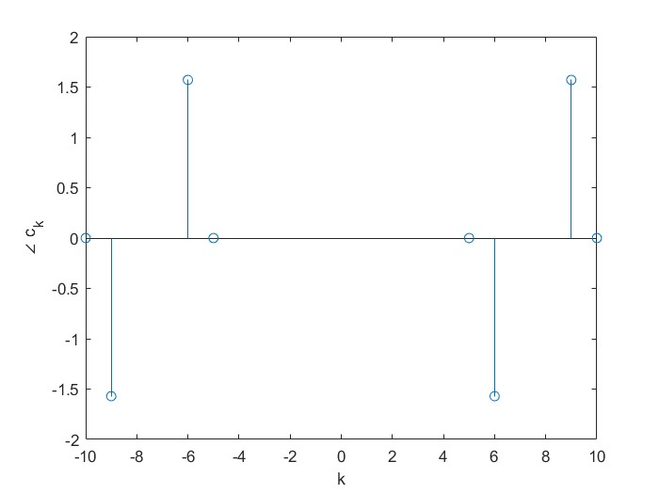

- The signal can be described as:

where
Given x(n), then

Therefore,

The coefficients can be further reduced using

Each coefficient can be described as magnitude and phase as follows

The spectrum can be described as follows

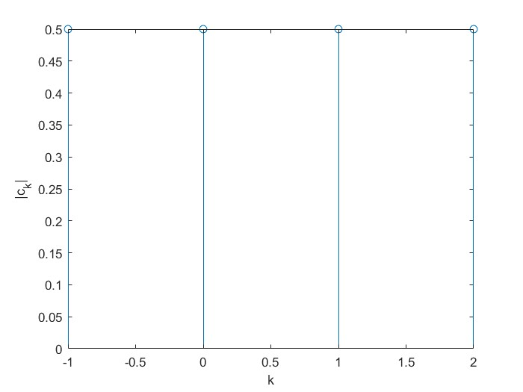

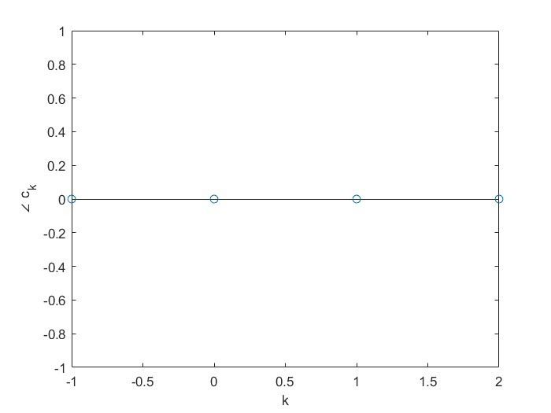

Problem 2
Find the Fourier Transform of the following signals:

Solution:

Problem 3
Using MATLAB or Python, if the Fourier Transform is complex, plot the magnitude and phase of the Fourier Transform of the signals given in Problem 2. If the Fourier Transform is real, plot the Fourier transform. In this problem, you do not need to use the Fourier Transform function. You are supposed to plot the expression you get in Problem 2.
Solution:
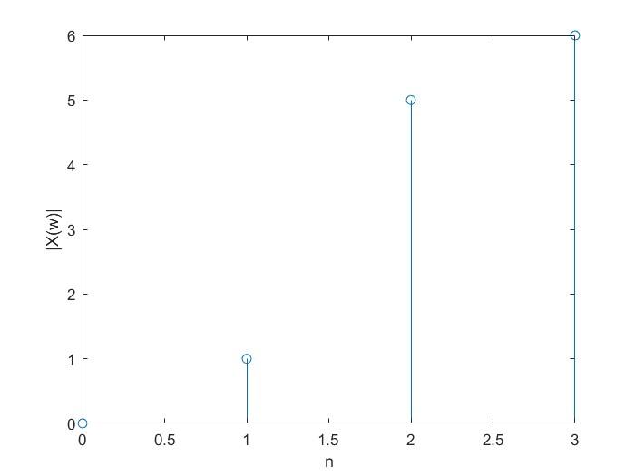

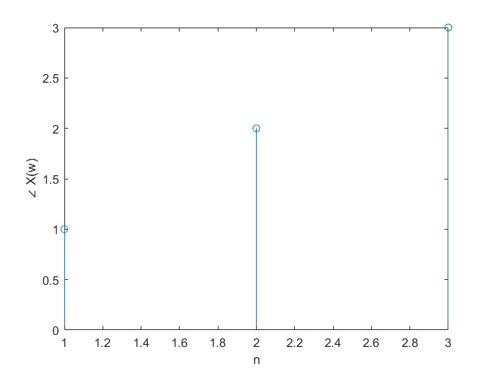

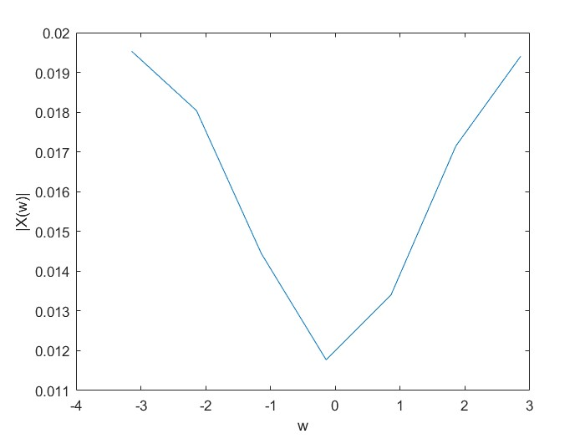

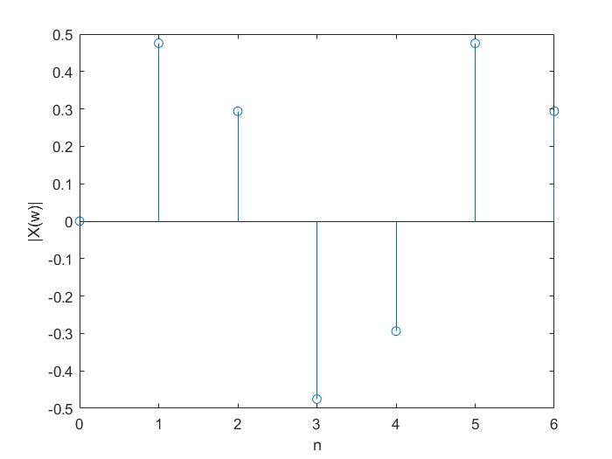

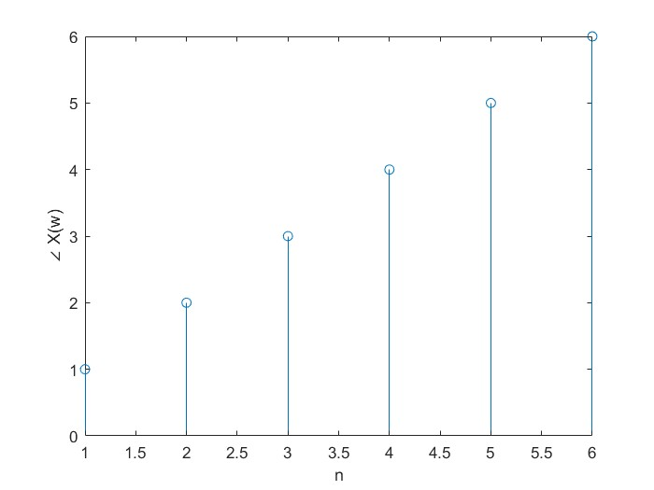

Problem 4
Implement the following functions using MATLAB or Python:
- ApplyDFT: A function that takes as input the file name of an input audio file, the length N of DFT, the length M of Inverse DFT, and the file name of the output audio file. This function should compute the N-point DFT of the input audio and then the M-point Inverse DFT of the obtained DFT. If the output of the Inverse DFT is complex, replace it with its magnitude.
- DropFrequencyRange: A function that takes as input the file name of an input audio file, the length N of DFT, the range of frequencies to drop (given as samples of the output DFT), and the file name of the output filtered audio file. This function should compute the N-point DFT of the input audio, replace the coefficients of the dropped frequencies by 0, then compute the N-point inverse DFT and save the output file. The function can use the function above ApplyDFT.
Deliverables:
- Your code (either MATLAB .m files or Python .py or Jupyter notebook files).
- Apply the function ApplyDFT to the audio file provided “Audio.wav” (N = 441000, M = 441000), (N = 220500, M = 220500), (N = 441000, M = 220500), and (N = 220500, M = 441000). Name the output audio files “Inverse_X_Y.wav”, where X = N and Y = M.
- For each case in (ii), plot the original signal and the signal obtained after applying the Inverse DFT on the same plot. Name the output images as “Inverse_X_Y.jpg”, where X = N and Y = M.
- Based on the outcomes in (ii) and (iii), comment on the output when M = N and less than the length of the original signal, when M < N, and when M > N.
- Apply the function DropFrequencyRange to the audio file provided “Audio.wav” with N = 441000 and the following range of frequencies given as samples of the DFT as follows (1000, 30000), (100, 30000), and (30000, 40000). Name the output audio files “Drop_1000_30000.wav”, “Drop_100_30000.wav”, and “Drop_30000_40000.wav”, respectively.
- For each case in (v), plot the original signal and the signal obtained after applying the function on the same plot. Name the output images as “Drop_1000_30000.jpg”, “Drop_100_30000.jpg”, and “Drop_30000_40000.jpg”.
- Based on the outcomes in (v) and (vi), comment on the output based on the change in the range.
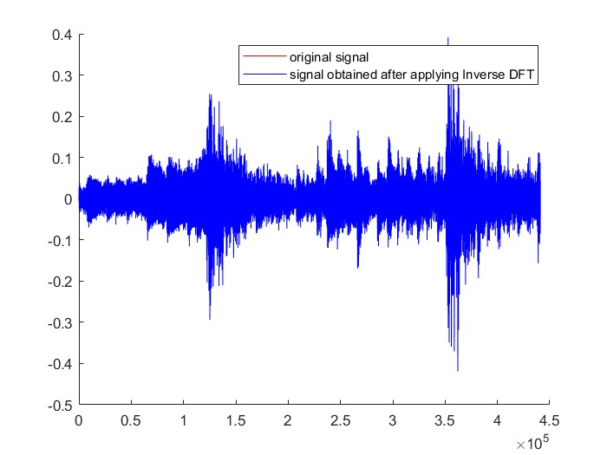

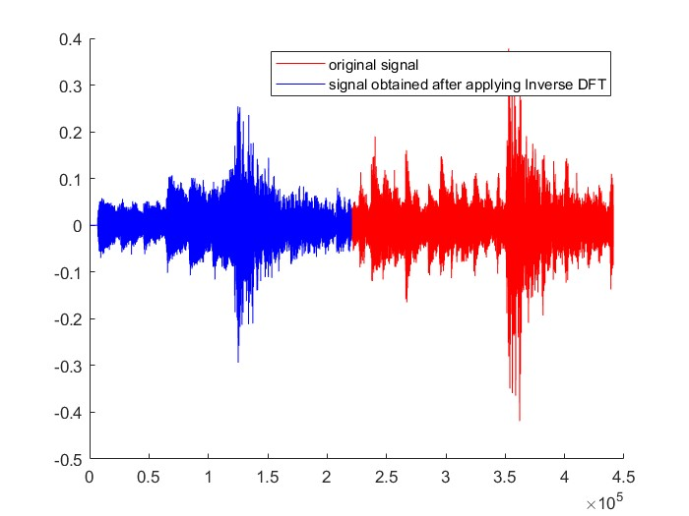

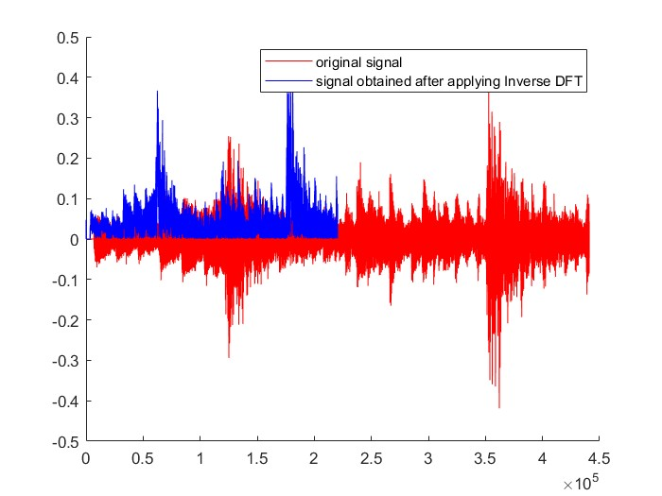

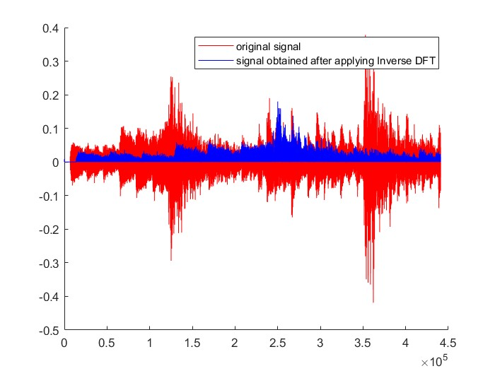

The output when N = M and less than the length of the original signal is better than the output when N > M and the output when N < M. The output when N < M has the same length as that of the original signal. The output when N > M has half the length as that of the original signal.

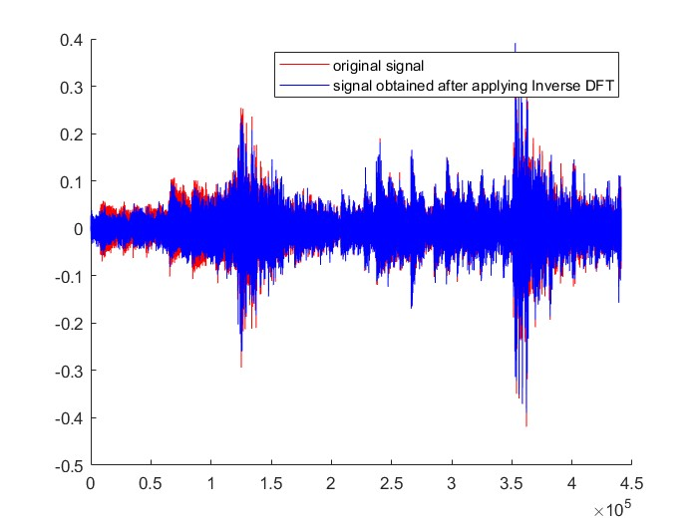

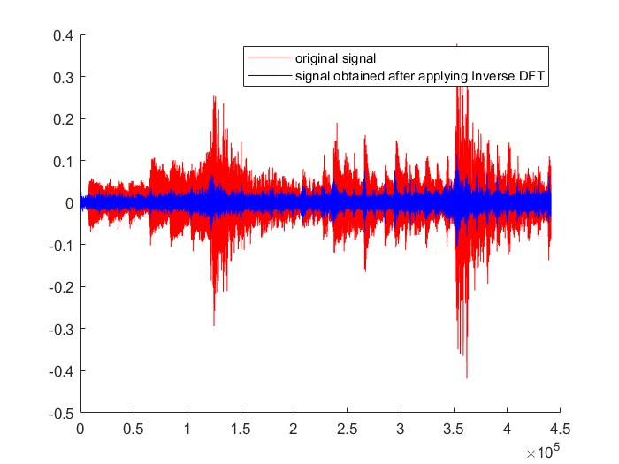

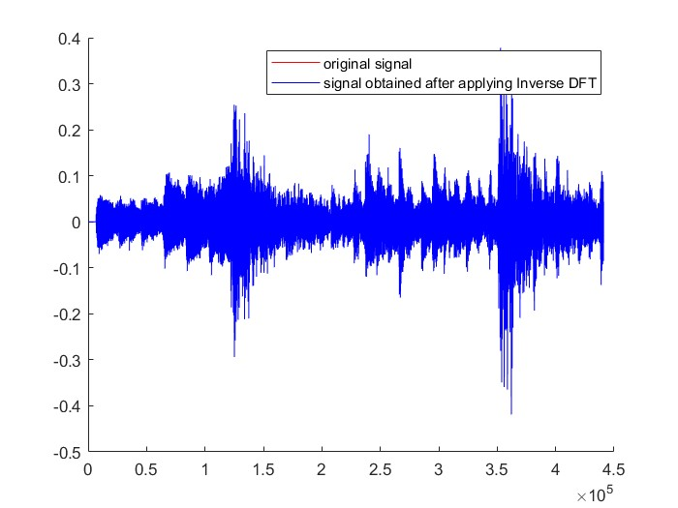

When the range of frequencies was (1000, 30000), the output was similar to the original signal. When the range of frequencies was (100, 30000), the output was very different from the original signal. When the range of frequencies was (30000, 40000), the output was nearly identical to the original signal.
Important Notes:
- All deliverables should be included in one .zip file.
- For Problems 1 and 2, a scanned version of handwritten solutions is acceptable.
- For Problem 3, include the plots in a report.
- For Problem 4, you can use DFT, Inverse DFT, and any necessary functions available in MATLAB or Python.
- Include the plots of Problem 4 in the report along with the comments required in parts (iv) and (vii).
- This is an individual assignment.

